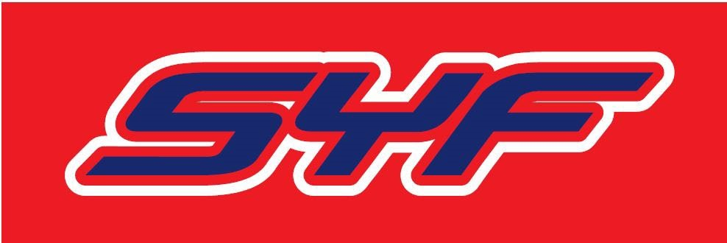
Annual Team Declaration of Compliance
We, ____Colusa Jr Redhawks_(School / Team), a youth sports organization, hereby providing this Annual 2024 Declaration pursuant to the California Youth Football Act (AB 1) and all of its provisions, in addition to the agreed and executed SYF Team Contract as well as the SYF Code of Conduct, understanding and personally affirming that the above Team, its Board, coaches, parents, have or shall complete all of the following:
- Obtain DOJ clearance for all coaches and administrators in compliance with all applicable regulations before participation and make available to SYF if requested;
- Remain in good standing with all government agencies and satisfy insurance;
- Obtain proper certification and registration of all coaches and youth participants prior to SYF participation (including physicals, signed Code of Conduct, residency, etc.);
- A tackle football team shall not conduct more than two full-contact practices per week during the preseason and regular season;
- The full contact portion of a practice shall not exceed 30 minutes in any single day;
- A coach shall annually receive a tackling and blocking certification from a nationally recognized program to minimize the risk of the involvement of a participant’s head from all tackling and blocking techniques;
- Concussion and head injury education per Section 124235 (this includes each parent or guardian);
- Opioid Factsheet for Patients per Section 124236 (this includes each parent or guardian);
- Training in the basic understanding of the signs, symptoms, and appropriate responses to heat-related illness;
[continued on page 2]
(SYF Annual Team Declaration of Compliance for 2024, page 2)
- Each football helmet shall be conditioned and recertified every other year;
- A minimum of one state-licensed EMT or higher-level professional (with authority to remove a participant) shall be present during all games;
- A coach shall receive first aid, cardiopulmonary resuscitation, and automated external defibrillator (AED) certification;
- At least one independent non-rostered individual (licensed in first aid, cardiopulmonary and AED protocols) shall be present at all practices;
- Safety equipment shall be inspected before every full contact practice or game;
- Each participant removed pursuant to this section shall comply with Section 124235 (return to play protocols – no participation in a game for at least 10 days if concussed) and shall be reported by the team to SYF; and
- Each participant shall complete a minimum of 10 hours of noncontact practice at the beginning of each season for the purpose of conditioning.
As an express part and condition of this Declaration of Compliance, I, for myself and as an authorized representative on behalf of my team, hereby release, indemnify, and hold harmless Sacramento Youth Football (SYF), its Commissioners, officers and board members, officials, agents, representatives, attorneys, and/or staff, to the fullest extent permitted by law inclusive of payment of reasonable costs and attorneys’ fees (venue is County of Placer), with respect to any and all claims or demands of any kind made by any government, person or entity in connection with this declaration and terms set forth herein.
This declaration shall be provided to SYF and posted on the team’s internet website.
By signing below, I certify and affirm the above requirements have been or shall be met in order to be in good standing with SYF and further I am duly authorized and have the authority on behalf of my Team to execute this declaration under California law. (Revised 01/23/2024)
Date: 2/21/2024
- Signed by_
- Print Name / Title: Victor Muniz
- President Victor Muniz

